**Variable Descriptions for NC Birth Data (2003-2007)**

The variables in this dataset that are in all CAPS are described in the Codebook file available on my course1 website. The variables that are not in all CAPS are ones I created for you from those in the original database. I will describe only those I created and refer you to the codebook for the others.

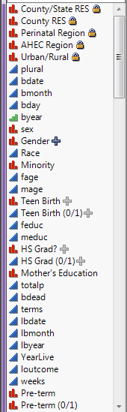

Perinatal Region - <http://ncbfc.org/about-us/perinatal-care-regions/>  
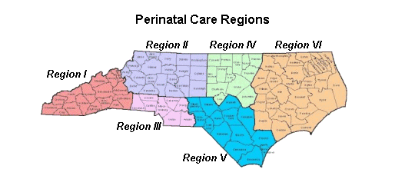

AHEC Region – <https://www.med.unc.edu/ahec/edu.htm>

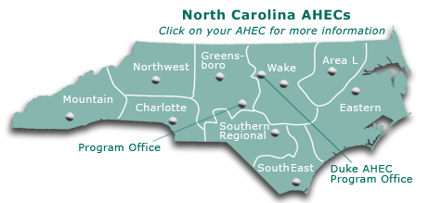

Urban/Rural – indicator of whether the county is consider urban or rural.

Gender – gender of infant (M or F)

Minority – White vs. Non-white ethnicity.

Teen Birth – mother was a teenager? (N/Y)

Teen Birth (0/1) – mother was a teenager (0 = no, 1 = yes)

HS Grad – was mother a high school grad/GED (N/Y)

HS Grad (0/1) – was mother a high school grad (0 = no, 1 = yes)

Mother’s Education – ordinal variable based on years of education  
(1 = < 10 yrs., 2 = 10 – 12 yrs., 3 = 12+ yrs.)

Pre-term – was infant born pre-term (N/Y)

Pre-term (0/1) – was infant born pre-term (0 = no, 1 = yes)

Marital Status – Married or Single

YearTerm – years since previous termination (don’t use)

PrevTerm – previous pregnancy termination (N/Y)

PrevTerm (0/1) – previous pregnancy termination (0 = no, 1 = yes)

See the link above for information about NC Area Health Education Centers.

See the link above for information about Perinatal Regions

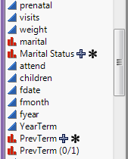

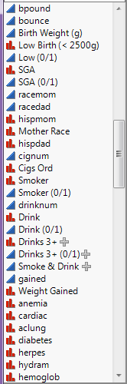

Birth Weight (g) – birth weight in grams

Low Birth (< 2500 g) – indicator of low birth weight (< 2500 g) (N/Y)

Low (0/1) – indicator of low birth weight (0 = no, 1 = yes)

SGA – indicator of small for gestational age (SGA) which is defined as having a birth weight below the 10th percentile given the gestational age in weeks. (N/Y)

SGA (0/1) – indicator of SGA (0 = no, 1 = yes)

Mother’s Race – American Indian (Am.Ind), Asian/Pacific Islander (API), Black, Hispanic, Other, or White

Cigs Ord – ordinal variable created based upon number of cigarettes per day (cignum) coded as: 0 = non-smoker, 1 = Cigs (1-5 per day), 2 = Cigs (6 – 10 per day), 3 = Cigs (10 – 20 per day), 4 = Cigs (20+ per day)

Smoker – smoked during pregnancy (N/Y)

Smoker (0/1) – smoked during pregnancy (0 = no, 1 = yes)

Drink – mother drank alcohol during pregnancy (N/Y)

Drink (0/1) – mother drank alcohol during pregnancy (0 = no, 1 = yes)

Drinks 3+ - mother drank 3 or more drinks per day (N/Y)

Drinks 3+ (0/1) – mother drank 3 or more drinks/day (0 = no, 1 = yes)

Smoke & Drink – mother smoked and drank alcohol during pregnancy (0 = no, 1 = yes)

Weight Gained – mother gained 41 or more lbs. during pregnancy (N/Y). Note: a group last year found this classification in their literature review

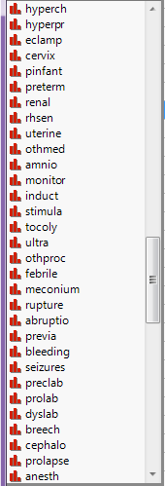

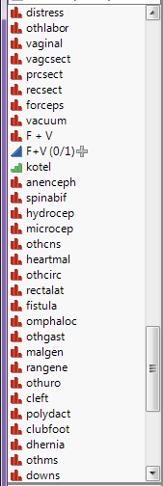

F + V – were forceps and/or vacuum used (N/Y)

F + V (0/1) – were forceps and/or vacuum used (0 = no, 1 = yes)

**IMPORTANT NOTE:** To convert a N/Y variable to a 0/1 variable which would then be suitable for mapping you need to add a new column to the spreadsheet using a formula to define it. In the JMP calculator select the **Conditional > If** option and build an expression that looks like the one shown below. Here I am creating a 0/1 variable which is indicator for the use of forceps and/or vacuum. This process can used for a multitude of dichotomous categorical variables in these data.

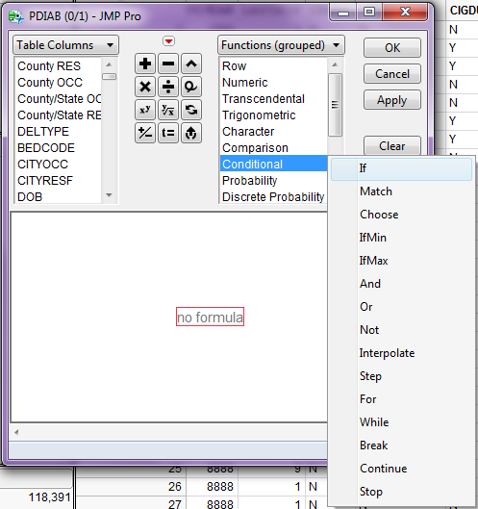

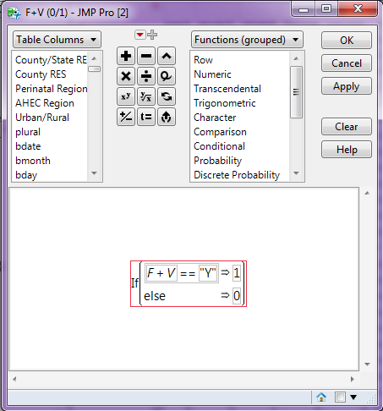

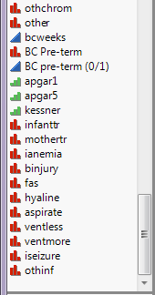

bcweeks – weeks of gestation estimated/determined from birth certificate

BC Pre-term – pre-term birth indicator based upon bcweeks (N/Y)

BC Pre-term – pre-term birth indicator based upon bcweeks (0 = no, 1 = yes)

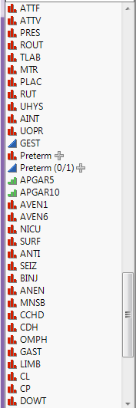   
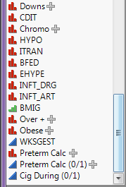

Preterm – infant born < 37 weeks gestation (Y or N)

Preterm (0/1) – infant born < 37 weeks (1 = Y or 0 = N)

Downs (Y/N) – Eliminates unconfirmed cases from DOWT

Chromo (Y/N) – Eliminates unconfirmed cases from CDIT

Over+ (Y/N) – Was mother classified as overweight or obese based on her BMI prior to pregnancy?

Obese (Y/N) – Was mother classified as obese based on her BMI prior to pregnancy?

Preterm Calc – Preterm status calculated from birth certificate (Y/N)

Preterm Calc (0/1) – Preterm status calculated from birth certificate (1 = yes, 0 = no)

Cig During (0/1) – Smoked during pregnancy (1 = yes, 0 = no)